FIRST 2021 Notes

# Infinite Recharge Season

* [FIRST Robotics Competition | FIRST (firstinspires.org)](https://www.firstinspires.org/robotics/frc)
* [INFINITE RECHARGE - Game & Season Materials | FIRST (firstinspires.org)](https://www.firstinspires.org/resource-library/frc/competition-manual-qa-system)
* Code to unlock this year’s manual and challenges:
  + !+Gam3^time#2021
* Beyond the Bots
  + [FIRSTinspires - Twitch](https://www.twitch.tv/firstinspires)
* YouTube:
  + [(46) FIRSTRoboticsCompetition - YouTube](https://www.youtube.com/firstroboticscompetition)

# Three possible opportunities:

1. Innovation Challenge (sponsored by Qualcom)
   1. [Innovation at FIRST | FIRST (firstinspires.org)](https://www.firstinspires.org/community/innovation)
   2. [2021 At Home Challenges Manual (windows.net)](https://firstfrc.blob.core.windows.net/frc2021/Manual/AtHomeManualSections/2021AtHomeChallengesManualSection04.pdf)
   3. What it means to be an innovator
   4. Find solutions of society’s many challenges.

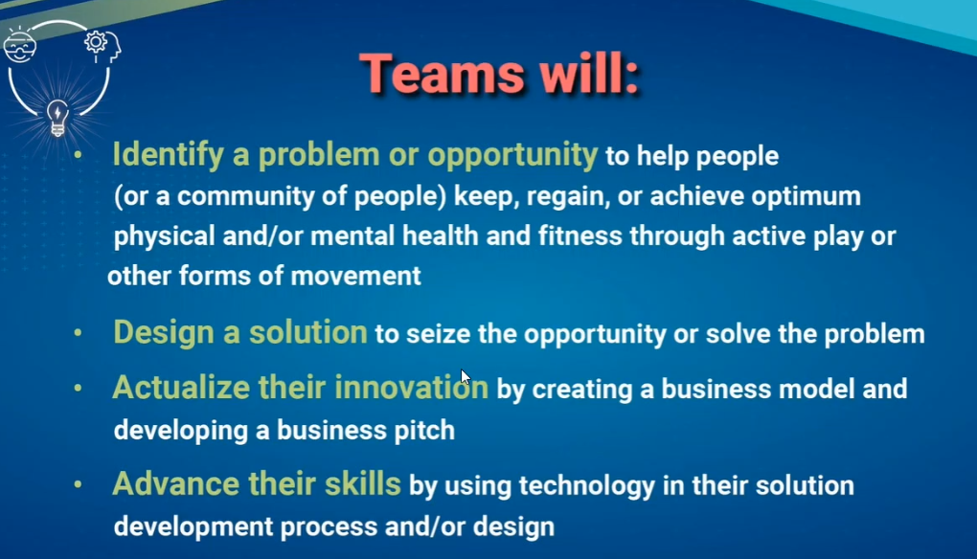

1. Infinite Recharge at Home
   1. [INFINITE RECHARGE at Home | FIRST (firstinspires.org)](https://www.firstinspires.org/resource-library/frc/infinite-recharge-at-home)
   2. [2021 At Home Challenges Manual (windows.net)](https://firstfrc.blob.core.windows.net/frc2021/Manual/AtHomeManualSections/2021AtHomeChallengesManualSection02.pdf)
   3. Skills challenges
   4. Judged machine awards

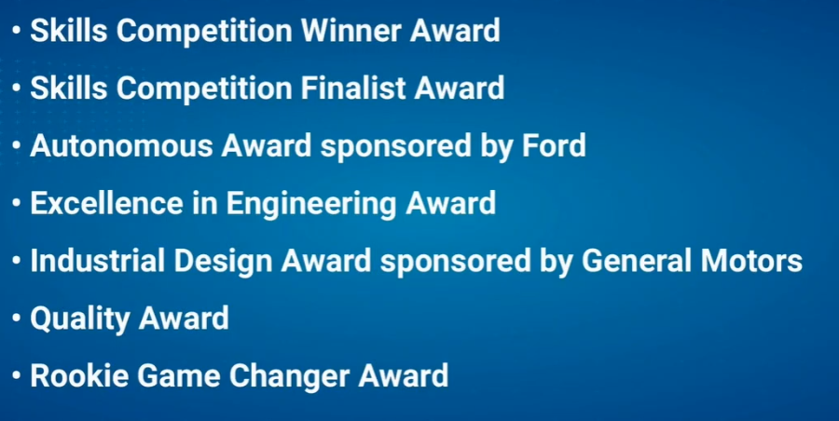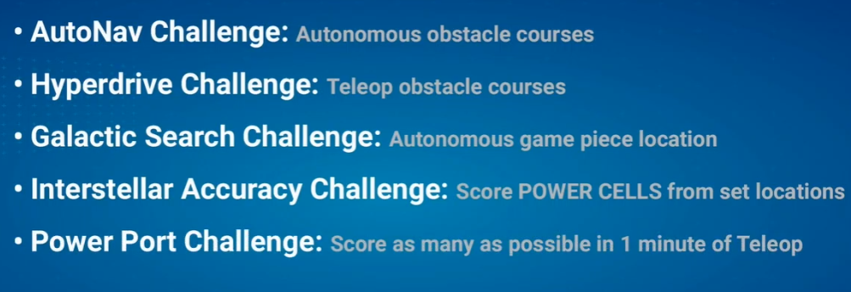

1. Game Design
   1. [Game Design Challenge | FIRST (firstinspires.org)](https://www.firstinspires.org/resource-library/frc/game-design-challenge)
   2. [2021 At Home Challenges Manual (windows.net)](https://firstfrc.blob.core.windows.net/frc2021/Manual/AtHomeManualSections/2021AtHomeChallengesManualSection03.pdf)
   3. Design a game that can be used in future competition.
   4. Must be unique.

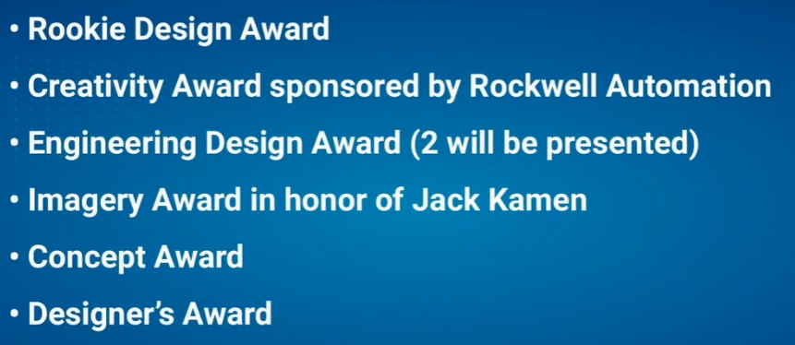

## General Questions

* Do we do all three? Pick and choose?
* Mow much do we focus on aspects other than robotics (entrepreneurship, service, business, etc.)?
* What is difference between First Tech Challenge and First Robotics?

# Kickoff Kit

1. Did we get it?